**Exercise: 01**

Create a stored procedure DISPLAY without parameters. The procedure must display

empno, ename and salary of all the employees of DEPTNO = 10.

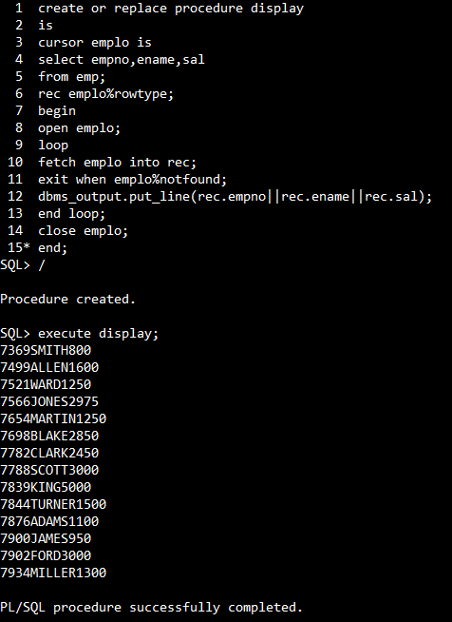

**Exercise: 02**

Create a stored procedure DISPLAY2 with parameters. It must take DEPTNO as an

input and must return the DNAME and TOTAL SALARY of the input department

number. DISPLAY2 procedure must be called from the PL/SQL anonymous block.

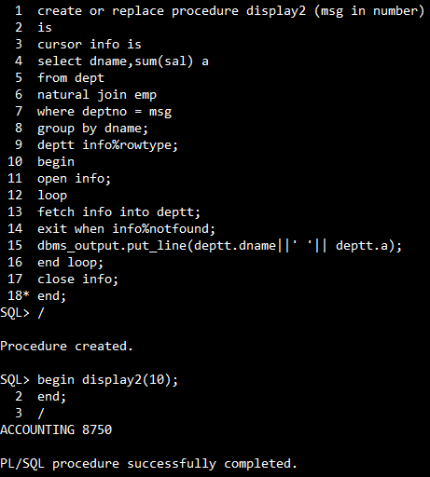

**Exercise: 03**

Create a stored procedure DISPLAY3 with parameters. It must take DEPTNO as an

input and must return the DNAME, SMALLEST and HIGHEST SALARIES of the

input department number. DISPLAY3 must also display empno,ename,total salary

(sal+comm) of all the employees of the input department number.

DISPLAY3 procedure must be called from the PL/SQL anonymous block.

